**Chapter 2.**

**2021. 03. 09.**

**Problem 2-35**

Calculate the formal charges on the atoms shown in red.

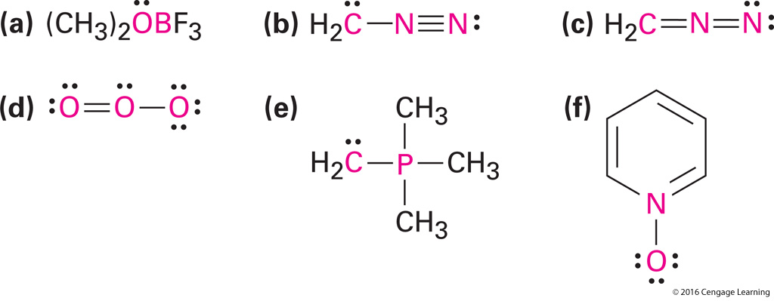

**Problem 2-38**

Draw as many resonance structures as you can for the following species:

